**EMEWS – 2022 EMOA AGM Special**

Below, please find information on the EMOA AGM.

First, there is an agenda for the session, then directions for getting to the venue and finally the minutes of the last AGM.

**The 58th East Midlands Orienteering Association AGM**

**Notice is hereby given that the Annual General Meeting of the East Midlands Orienteering Association will be held at 7.30pm on Monday 12th September 2022 at the Pace Room, Clifton, Nottingham**

**AGENDA**

1. Apologies for absence

2. Approval of minutes of last AGM September 13th 2021

3. Chair’s Report

4. Financial Secretary’s report including membership numbers and presentation of accounts

5. Approval of Balance Sheet and Income and Expenditure Statement

6. Election of Principal Officers

Chair

Vice Chair

Financial Secretary

Development Co-ordinator

7. Other EMOA Officers

|  |  |
| --- | --- |
| **Post** | **Nominee** |
| Mapping | David Olivant (NOC) |
| Coaching | Hilary Palmer (NOC) |
| EM Junior Squad | Ann-Marie Duckworth (DVO), aided by Ant Squire (NOC) |
| EM League | Ursula Williamson (LEI) |
| Urban League | Ursula Williamson (LEI) |
| Regional Fixtures Secretary | Ursula Williamson (LEI) |
| President | John Woodall (NOC) |
| Minutes Secretary | Mike Gardner (DVO) |
| EMEWS Editor | Mike Gardner (DVO) |
| Webmaster | John Cooke (DVO) |
| National Forest | Roy Denney (LEI) |

8. Appointment of Independent Financial Examiner

9. Budget projections for coming year to 30.6.2023 and recommendations for membership fees and event levies (Financial Secretary)

9a Recommend the level of the identified reserves for EMOA, currently set at a level of £10,000

10. Fixing of charges

Membership fees

Event Levies

11. Changes to the EMOA Constitution

The following changes are proposed for the EMOA constitution:

In the Financial Procedures section of the constitution, the term “Treasurer” is still used as opposed to Financial Secretary which is used in the rest of the constitution. There are currently 9 references to “Treasurer” which should all be changed to “Financial Secretary”.

12. Plans for the coming year (Chair)

13. Any Other Business

14. Close of formal meeting followed by open discussion

If anyone has any additional items they want adding to the agenda of the AGM, then please let EMOA Secretary (Mike Gardner) know. Also if anyone wants to send apologies please also let Mike know.

**Pace Room Clifton directions**

The Pace Room is in Clifton Village, Nottingham, just off the A453.

Turn into Clifton Village and take Village Road, stay on Village Road as it goes round to the left. It comes to what seems to be a T junction, but the main road continues to the right and becomes Holgate. Just before the gates to Clifton Hall there is a small car park on the right.

Leaving the car park on foot, go into the churchyard to the left of the gates to Clifton Hall, and follow the path around the back of the church, which is where you will find the Pace Room.

**Alternative Attendance**

We will try to set up a Zoom session as well. If anyone wants to attend via Zoom can they let the secretary Mike Gardner know by September 10th and we will try to set up a Zoom link for you to attend ([mikegardvo@sky.com](mailto:mikegardvo@sky.com)).

If you want to send apologies for non-attendance, please also let Mike know.

**Constitution Changes**

As mentioned above there is one proposed change to the constitution. In the Financial Procedures section of the constitution, the term “Treasurer” is still used as opposed to Financial Secretary which is used in the rest of the constitution. There are currently 9 references to “Treasurer” which should all be changed to “Financial Secretary”.

No other changes to the constitution have been received.

**MINUTES OF THE 57th ANNUAL GENERAL MEETING OF THE EAST MIDLANDS ORIENTEERING ASSOCIATION HELD ON ZOOM ON MONDAY 13th SEPTEMBER 2021 AT 19.30.**

**Present:** Trudy Crosby (LOG), Ann-Marie Duckworth (DVO), Roger Edwards (LEI), Mike Gardner (DVO), Liz Godfree (DVO), Mike Godfree (DVO), Judith Holt (DVO), John Hurley (DVO), Vic Knight (NOC), David Olivant (NOC), Pauline Olivant (NOC), Chris Phillips (LEI), Hilary Palmer (NOC), John Palmer (NOC), Iain Phillips (LEI), Ursula Williamson (LEI), and John Woodall (NOC).

The meeting was held on Zoom and was quorate as more than 15 members were in attendance.

1. **Apologies for absence**:

Ranald Macdonald (DVO) and Paul Young (DVO) offered their apologies.

1. **Minutes of the 56th EMOA AGM held on Monday 14th  September 2020.**

**I**t was agreed that the minutes were a true record. Proposed by John Hurley (DVO) and seconded by John Woodall (NOC).

1. **Standing Order Change:**

There were no standing order changes submitted to this AGM.

1. **Chair’s Report:**

At last year’s AGM, in my future plans item, I did express a hope that we would have some return to normality over the Winter with something like our usual event programme. Alas, as you are all aware that was not to be and it was not until the early Summer this year that we have been able to have some return to competitive orienteering.

The process of restarting has, understandably, been slow, with issues relating to permissions, not all members feeling that they wanted to be at events and the Covid 19 restrictions themselves making life more difficult for event officials. It speaks a lot for the resilience of our club and event officials, that we have been able to achieve so much in the last few months.

Chinley Churn was the venue for the East Midlands Championships. Many thanks to DVO for hosting the event. NOC held the EM Sprint Championships at Trent University and surrounds, and LEI and LOG have got the 2021 EM Leagues out of the starting blocks.

With the lack of Orienteering there is not a great deal of EMOA success to report. I would like to congratulate Rachel Duckworth on being selected for Team GB for both the European Youth Champs and Junior World Champs; unfortunately, though Team GB were unable to compete at these events during to Covid restrictions.

Rachel has also been selected for the England team for the SeniorHome Internationals.

Congratulations are also due to Richard Robinson and Sally Calland for their age class wins in the British Sprint Championships.

Ann-Marie and Ant have worked wonders with EMJOS, in keeping its members engaged with the sport during the last year. Many thanks for that, it cannot have been easy.

Last year Amanda mentioned in her report, the innovative ways that clubs had developed to continue to engage the interests of their members. It has been good to see that this has continued over the last few difficult months. I do wonder if, in some aspects, the sport has changed forever. Will orienteers rely more on technology to get their regular O Fix?

Finally, my thanks to the officers and members of the EMOA committee for the hard work they have put in over the last year in very difficult conditions and for making my role as Chair so easy.

Chris Phillips

1. **Financial Secretary’s Report**

Paul Young circulated the accounts before the meeting to the committee for review

Below are Paul’s accounts with, in italics, comments raised during the meeting.

**Context**

The 2020/21 Financial Year was the second EMOA year to be impacted, in part, by the global COVID-19 pandemic. During the year in question the UK experienced several “lockdowns” along with changing guidance relating to internal and external travel all of which limited the region’s ability to arrange and partake in orienteering activity. The roll out of COVID-19 vaccines from late 2020 combined with the lifting of restrictions allowed clubs to successfully reintroduce local level events along with a few more significant regional and national events.

**Membership**

Membership as of 21 June 2021 of 485 is slightly down, by 19 members, on the previous year. The last decade has seen a continual decline in membership, cumulatively the region has seen a reduction of 40% over this time frame.

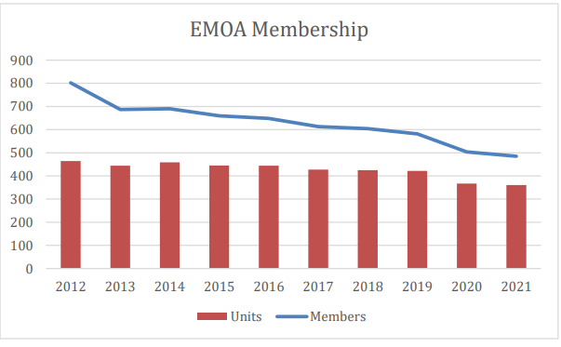

|  |  |  |
| --- | --- | --- |
|  | **Members** | **Units** |
| 2021 | 485 | 361 |
| 2020 | 504 | 367 |
| 2019 | 582 | 422 |
| 2018 | 604 | 425 |
| 2017 | 613 | 427 |
| 2016 | 648 | 444 |
| 2015 | 660 | 445 |
| 2014 | 690 | 459 |
| 2013 | 687 | 444 |
| 2012 | 802 | 464 |

2021 figures compared with 2020

|  |  |  |
| --- | --- | --- |
|  | **2021** | **2020** |
| Senior | 268 | 267 |
| Junior | 9 | 10 |
| Family | 84 (149s, 59j) | 90 (161s, 66j) |
| **Totals** | **361 units** | **367 units** |

**2020/21 Accounts**

The EMOA year end is 30th June 2021, Roger Edwards has reviewed the accounts and issued the following statement:

"I confirm that the accounts for the year ending 30th June 2021 are consistent with the underlying accounting records of the Association"

A copy of the noted accounts is attached for the record.

Roger is thanked for again being the independent financial examiner of the accounts.

EMOA generated a surplus of £1,156.62 for the 2020/21 year.

The Budget was for a loss of £(1,830).

Material variances to the Budget are set out below:

Membership – Whilst membership income was down year on year it was not as low as forecast. The roll out of vaccines and the relaxation of some restrictions in the early part of 2021 combined with the reintroduction of local events and MapRun courses, are likely to have helped keep membership renewals and thus income at a similar level to the previous year.

Event Levies – Events attracting an EMOA levy were severely impacted during the year by the pandemic. The forecast assumed a year-on-year reduction, however only six such events were possible, so income was materially lower than forecast. Clubs were however able to arrange plenty of lower-level events during the spring and summer of 2021 to meet the needs of members.

EMJOS income and fundraising – Income relating to EMJOS was minimal in the year due to COVID-19, however reserves were not affected as expenditure was also minimal.

EMJOS expenditure – Expenditure was significantly lower than budgeted largely due to the impact of COVID-19 on the number of training events which could be undertaken during the year.

Other costs – Expenditure across all other areas was minimal, again due to the uncertainties bought about by the ever-changing impacts of COVID-19

**2020/21 Income from event levies.**

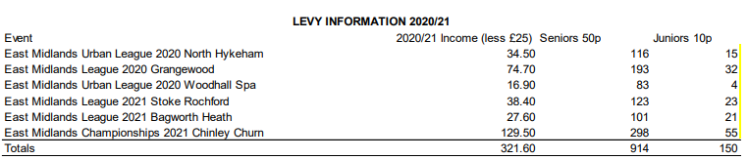

**Levies**

|  |  |  |  |  |  |  |  |
| --- | --- | --- | --- | --- | --- | --- | --- |
|  |  |  |  | Seniors | | Juniors | |
|  | Events | Levy | Entrants | Qty | % | Qty | % |
| 2020/21 | 6 | 322 | 1.064 | 914 | 86% | 150 | 14% |
| 2019/20 | 19 | 1,505 | 4,531 | 3,755 | 83% | 776 | 17% |
| 2018/19 | 24 | 1,502 | 4,739 | 4071 | 86% | 668 | 14% |
| 2017/18 | 25 | 1,367 | 4,560 | 3840 | 84% | 720 | 16% |
| 2016/17 | 30 | 1,747 | 6,093 | 4718 | 77% | 1375 | 23% |
| 2015/16 | 32 | 2,036 | 6,917 | 5360 | 77% | 1557 | 23% |
| 2014/15 | 24 | 1,665 | 5,744 | 4497 | 78% | 1247 | 22% |
| 2013/14* | 24 | 1,153 | 5,941 | 3868 | 65% | 2073 | 35% |
| *713 juniors 0 Seniors at Shipley Park Event | | | | | | | |
| 2012/13 | 24 | 1,413 | 6,121 | 4671 | 76% | 1450 | 24% |

The detailed accounts are provided below:

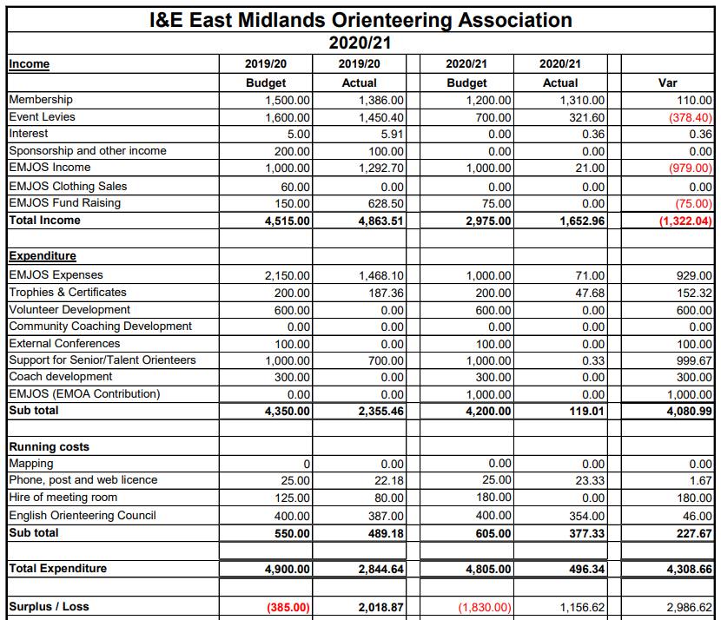

The Balance Sheet for 2020/21 is shown below:

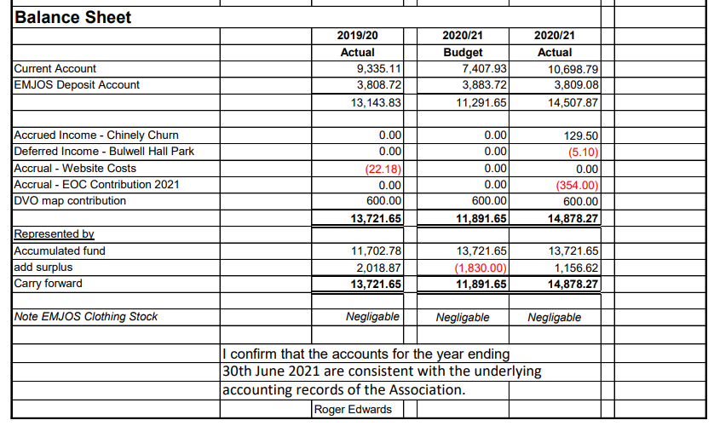

1. **Election of Principal Officers**:

Chris Phillips stated that we had the three main officers of chair, financial secretary and development officer who were willing to stand again next year. We were still short of a vice-chair. Chris asked if there were any other nominations for any of the key roles. There were no other nominations, so the 3 main officers were re-elected unanimously by the meeting.

The following were the re-elected nominees to stand as principal officers next year:

|  |  |
| --- | --- |
| **Post** | **Nominee** |
| Chair | Chris Philips (LEI) |
| Vice-Chair |  |
| Financial Secretary | Paul Young (DVO) |
| Development Officer | Ranald Macdonald (DVO) |

Chris emphasised the need to find a new vice-chair soon and said he would be willing to talk to anyone interested in the role.

1. **Other EMOA Officers**:

The club representatives on the EMOA Committee are nominated by clubs. Members holding non-elected roles with the association are currently:

|  |  |
| --- | --- |
| **Post** | **Nominee** |
| Mapping | David Olivant (NOC) |
| Coaching | Hilary Palmer (NOC) |
| EM Junior Squad | Ann-Marie Duckworth (DVO), aided by Ant Squire (NOC) |
| EM League | Ursula Williamson (LEI) |
| Urban League | Ursula Williamson (LEI) |
| Regional Fixtures Secretary | Ursula Williamson (LEI) |
| President | John Woodall (NOC) |
| Minutes Secretary | Mike Gardner (DVO) |
| EMEWS Editor | Mike Gardner (DVO) |
| Webmaster | John Cooke (DVO) |
| National Forest | Roy Denney (LEI) |

1. **Appointment of Independent Financial Examiner**:

Roger Edwards agreed to continue as Independent Financial Examiner for the next year.

1. **Approval of Balance Sheet and Income and Expenditure Statement**:

The proposed Budget for the year 2021/22 is set out below for the A.G.M.

I do not propose making any changes to the existing membership fees. Therefore, the fees are proposed to remain as follows:

Senior membership fee £3;

Junior membership fee £1;

Associate membership fee is £10; and

Club membership fee is £15.

Event levy income, from category C and above events - I propose event levies also remain unchanged for the 2021/22 financial year. 50p per adult and 10p per junior with the first £25 continuing to be retained by the organising club.

The EMOA contribution to junior squad spending shall be restricted to a maximum loss of £(1000), any extra spending to come from their deposit account and/or specific fundraising.

There is an increased budget for camps for both seniors and juniors. This is because a number of camps have been delayed to the second half of 2021 because of COVID, so they will now fall under this budget, but by next year the camps should be back to normal in the first part of the calendar year, so, in effect this year the budget needs to cover the camps for 2021 and 2022.

*It was noted that the EMJOS Funds are there for the use of the squad and recognised that they had saved quite a sum from cakes, hosting an event, etc. to fund the squad attending Sweden, but this had to be cancelled due to COVID. Those funds will therefore be for the use of the EMJOS Squad. In effect the EMJOS Squad has all the money in their current account, all participant contributions from cake stalls, etc., profit from events the squad have run, and the normal budget of £1,000 provided by EMOA.*

*It was noted that the EMJOS kit is now more or less all gone, and replenishment of stock would need to be financed in the coming year. Some of the £1,000 budget will be used to pay for this.*

*The biggest expense this financial year may be the attendance at the Junior Inter-Regionals where the costs are around £480 (as the attendees cover half the costs themselves).*

*It was noted that residential costs have gone up a lot in the last year, which may mean junior squad and other training or support for participants may require more funding.*

The proposed EMOA Budget for 2020/21 is a loss of £(3,137)

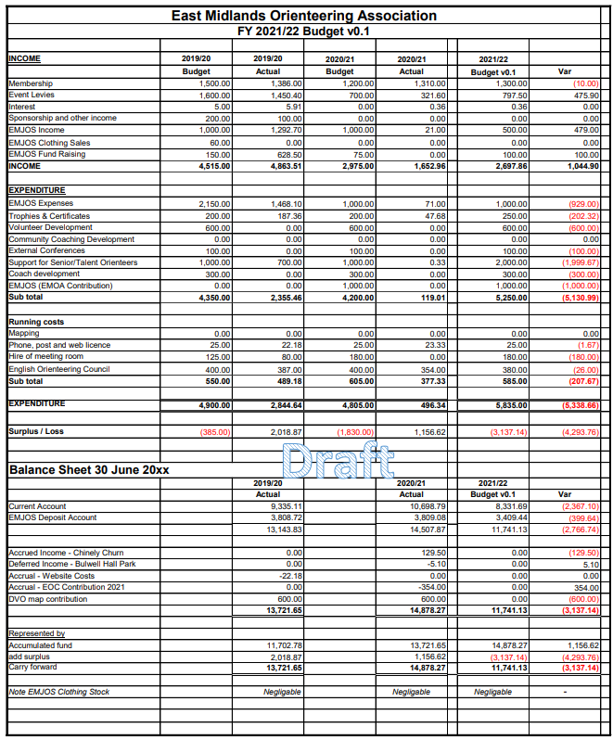

The draft budget was circulated in advance, but obviously there is some uncertainty on key income streams.

The proposed fees and income and expenditure were proposed to be accepted by the meeting

Proposed: John Hurley (DVO)

Seconded: Ursula Williamson (LEI)

This was agreed unanimously by the meeting.

1. **Plans for Coming Year:**

One would hope that the next year will see something that passes for normal in Orienteering. Unfortunately, even with aid of my trusty crystal ball, forecasting what the next few months will bring is very difficult.

The intention is to run both the Forest and Urban Leagues as normal, and we have had commitments from the clubs in the Association to hold the usual number of events. However, in some cases that will depend on permissions being given by landowners and, as I think most members know, land access has been rather more difficult since the start of the pandemic. I feel that it should also be noted that access fees have risen significantly in recent months.

Ann-Marie and Ant have already circulated their plans for EMJOS for the coming year and it is a full and busy programme. I hope that clubs will endeavour to promote the benefits of being members of EMJOS to the juniors in their clubs.

In his role as Regional Development Officer, Ranald is planning a training day for Controllers and Planners. Date to be confirmed.

In October, we have what is almost going to be a Regional Day Out at the SYO area at Tankersley as three of the four clubs in the Association have qualified for the Compass Sport Cup Final - albeit from 2020.

The Orienteering Foundation is supporting another Coaching day in the South Lakes on Saturday 20th November. Individuals are very welcome to attend, and coaching will be provided but it is hoped that clubs will take a group with their own coaches. Why not make a weekend away with a regional event at Great Tower on the Sunday?

During 2022, NOC will be hosting the Midlands Championships in Sherwood Forest, and DVO will be responsible for the EM Championships at Stanton Moor. LEI are hosting the Yvette Baker Trophy Final at Irchester, and DVO the British Schools Score Championships at Shipley Park. Looking further ahead to JK 2024, which we are jointly organising with WMOA, an initial meeting is planned for October with representatives of the two clubs involved, DVO and LEI, and the JK Co-Ordinator Andy Yeates.

On a slightly less positive note, as has been mentioned, earlier in the meeting, membership numbers in the Association continue to fall. Apart from the concern that if numbers continue to fall there comes a point at which the Association is no longer viable, the drop in numbers will inevitably impact on entries for events. There is also the concern that we will not have sufficient event officials and helpers to run the number of events that we would wish. I am of the view that the Association will have to spend sometime in the forthcoming year looking at this issue and making plans for how we move forward.

Chris Phillips

1. **Any Other Business:**

* John Woodall stated that committee meetings have been held in Clifton previously and wanted to know if we should continue to do this or use Zoom as had been done for the last year of COVID. After some discussion it was agreed that for now the first meeting of the year would be held in person at Clifton to allow the new committee to meet face to face (especially if there were new officials). Then, the rest of the meetings could be held using Zoom to save committee members travelling time. Based on this John agreed to book the PACE Room in Clifton for the 15th November committee meeting.

1. **Close of formal meeting:**

The meeting was formally closed at 20:10.